**Lab TASK 6 WITH SOLUTIONS**

1. [**Write a C program to Store Information in Structure and Display it**](https://techstudy.org/cLanguage/Write-a-C-program-to-Store-Information-in-Structure-and-Display-it)**.**

**#include <stdio.h>**

**struct student**

**{**

**char name[50];**

**int roll;**

**float marks;**

**}**

**stud[2];**

**int main()**

**{**

**int i;**

**printf("Enter information of students:\n");**

**// storing information**

**for(i=0; i<2; ++i)**

**{**

**stud[i].roll = i+1;**

**printf("\nFor roll number: %d\n",stud[i].roll);**

**printf("Enter name: ");**

**scanf("%s",stud[i].name);**

**printf("Enter marks: ");**

**scanf("%f",&stud[i].marks);**

**printf("\n");**

**}**

**printf("Displaying Information:\n\n");**

**// displaying information**

**for(i=0; i<2; ++i)**

**{**

**printf("\nRoll number: %d\n",i+1);**

**printf("Name: ");**

**puts(stud[i].name);**

**printf("Marks: %.1f",stud[i].marks);**

**printf("\n");**

**}**

**return 0;**

**}**

**Output:**

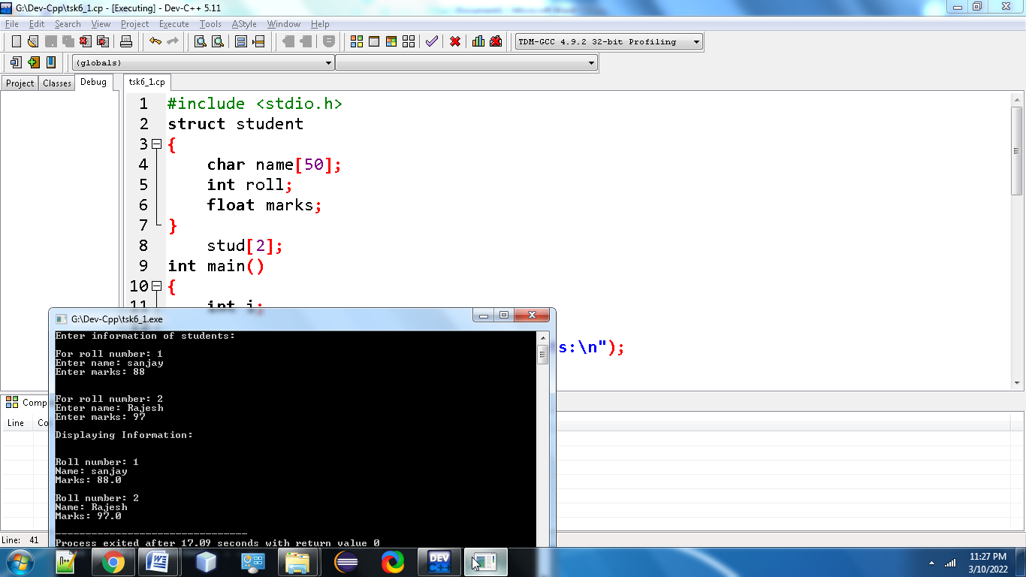

**2.** [**Write a C Program to add two distances in inch-feet system using Structure**](https://techstudy.org/cLanguage/Write-a-C-program-to-add-two-distances-in-inch-feet-system-using-Structure)

**#include <stdio.h>**

**struct Distance {**

**int feet;**

**float inch;**

**} d1, d2, result;**

**int main() {**

**printf("Enter 1st distance\n");**

**printf("Enter feet: ");**

**scanf("%d", &d1.feet);**

**printf("Enter inch: ");**

**scanf("%f", &d1.inch);**

**printf("\nEnter 2nd distance\n");**

**printf("Enter feet: ");**

**scanf("%d", &d2.feet);**

**printf("Enter inch: ");**

**scanf("%f", &d2.inch);**

**// adding distances**

**result.feet = d1.feet + d2.feet;**

**result.inch = d1.inch + d2.inch;**

**// convert inches to feet if greater than 12**

**while (result.inch >= 12.0) {**

**result.inch = result.inch - 12.0;**

**++result.feet;**

**}**

**printf("\nSum of distances = %d\'-%.1f\"", result.feet, result.inch);**

**return 0;**

**}**

**Output:**

**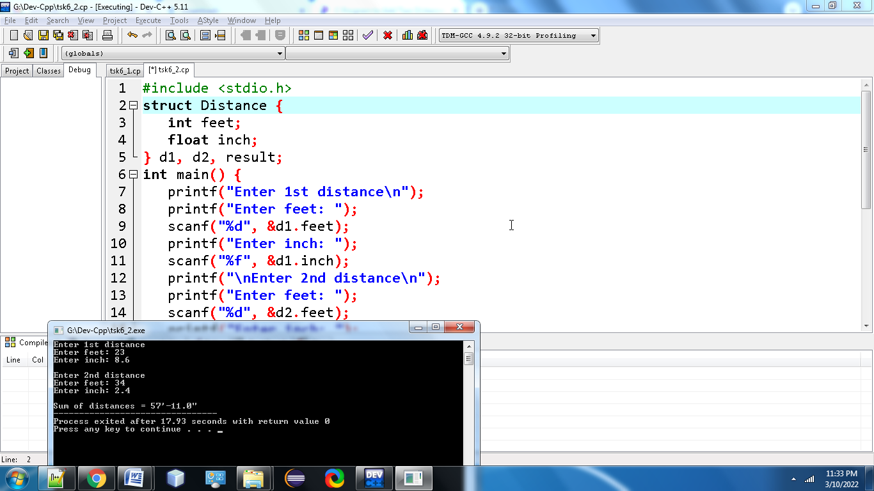**

**3.[Write a C Program to Calculate Difference Between Two Time Periods](https://techstudy.org/cLanguage/Write-a-C-program-to-Calculate-Difference-Between-Two-Time-Periods" \t "_blank)?**

**#include <stdio.h>**

**struct TIME**

**{**

**int seconds;**

**int minutes;**

**int hours;**

**};**

**void differenceBetweenTimePeriod(struct TIME t1, struct TIME t2, struct TIME \*diff);**

**int main()**

**{**

**struct TIME startTime, stopTime, diff;**

**printf("Enter start time: \n");**

**printf("Enter hours, minutes and seconds respectively: ");**

**scanf("%d %d %d", &startTime.hours, &startTime.minutes, &startTime.seconds);**

**printf("Enter stop time: \n");**

**printf("Enter hours, minutes and seconds respectively: ");**

**scanf("%d %d %d", &stopTime.hours, &stopTime.minutes, &stopTime.seconds);**

**// Calculate the difference between the start and stop time period.**

**differenceBetweenTimePeriod(startTime, stopTime, &diff);**

**printf("\nTIME DIFFERENCE: %d:%d:%d - ", startTime.hours, startTime.minutes, startTime.seconds);**

**printf("%d:%d:%d ", stopTime.hours, stopTime.minutes, stopTime.seconds);**

**printf("= %d:%d:%d\n", diff.hours, diff.minutes, diff.seconds);**

**return 0;**

**}**

**void differenceBetweenTimePeriod(struct TIME start, struct TIME stop, struct TIME \*diff)**

**{**

**if(stop.seconds > start.seconds){**

**--start.minutes;**

**start.seconds += 60;**

**}**

**diff->seconds = start.seconds - stop.seconds;**

**if(stop.minutes > start.minutes){**

**--start.hours;**

**start.minutes += 60;**

**}**

**diff->minutes = start.minutes - stop.minutes;**

**diff->hours = start.hours - stop.hours;**

**}**

**Output: 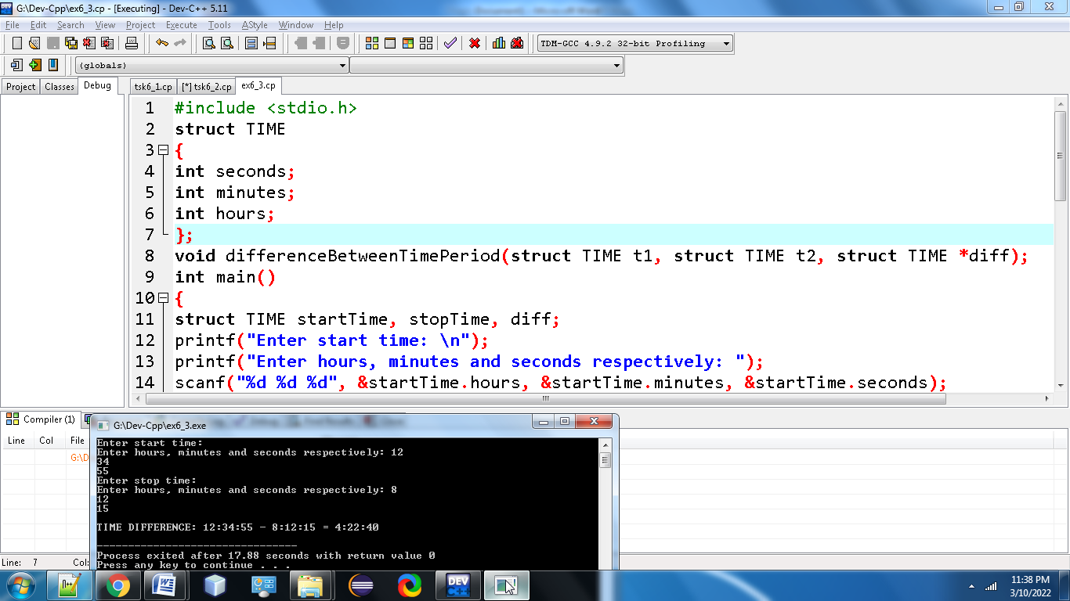**

**4.[Write a C program to demonstrate example of Nested Structure](https://techstudy.org/cLanguage/Write-a-C-program-to-demonstrate-example-of-Nested-Structure" \t "_blank)?**

**#include <stdio.h>**

**struct student{**

**char name[30];**

**int rollNo;**

**struct dateOfBirth{**

**int dd;**

**int mm;**

**int yy;**

**}DOB; /\*created structure varoable DOB\*/**

**};**

**int main()**

**{**

**struct student std;**

**printf("Enter name: "); gets(std.name);**

**printf("Enter roll number: "); scanf("%d",&std.rollNo);**

**printf("Enter Date of Birth [DD MM YY] format: ");**

**scanf("%d%d%d",&std.DOB.dd,&std.DOB.mm,&std.DOB.yy);**

**printf("\nName : %s \nRollNo : %d \nDate of birth : %02d/%02d/%02d\n",std.name,std.rollNo,std.DOB.dd,std.DOB.mm,std.DOB.yy);**

**return 0;**

**}**

**Output: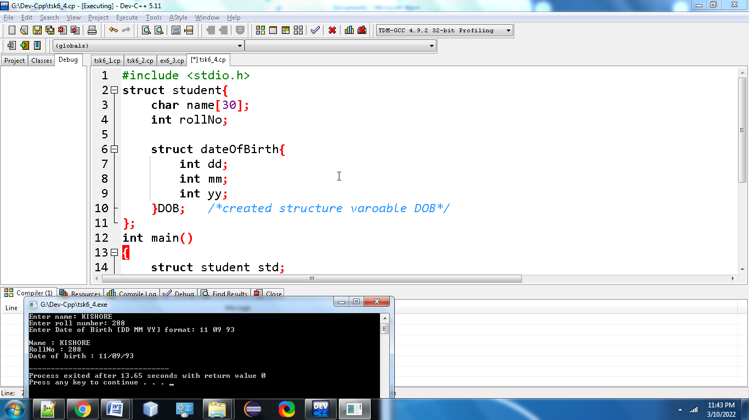**

**5.** [**Write a C program to demonstrate example of structure pointer**](https://techstudy.org/cLanguage/Write-a-C-program-to-demonstrate-example-of-structure-pointer)**?**

**#include <stdio.h>**

**struct item**

**{**

**char itemName[30];**

**int qty;**

**float price;**

**float amount;**

**};**

**int main()**

**{**

**struct item itm;**

**struct item \*pItem;**

**pItem = &itm;**

**printf("Enter product name: ");**

**gets(pItem->itemName);**

**printf("Enter price:");**

**scanf("%f",&pItem->price);**

**printf("Enter quantity: ");**

**scanf("%d",&pItem->qty);**

**pItem->amount =(float)pItem->qty \* pItem->price;**

**printf("\nName: %s",pItem->itemName);**

**printf("\nPrice: %f",pItem->price);**

**printf("\nQuantity: %d",pItem->qty);**

**printf("\nTotal Amount: %f",pItem->amount);**

**return 0;**

**}**

**Output:**

**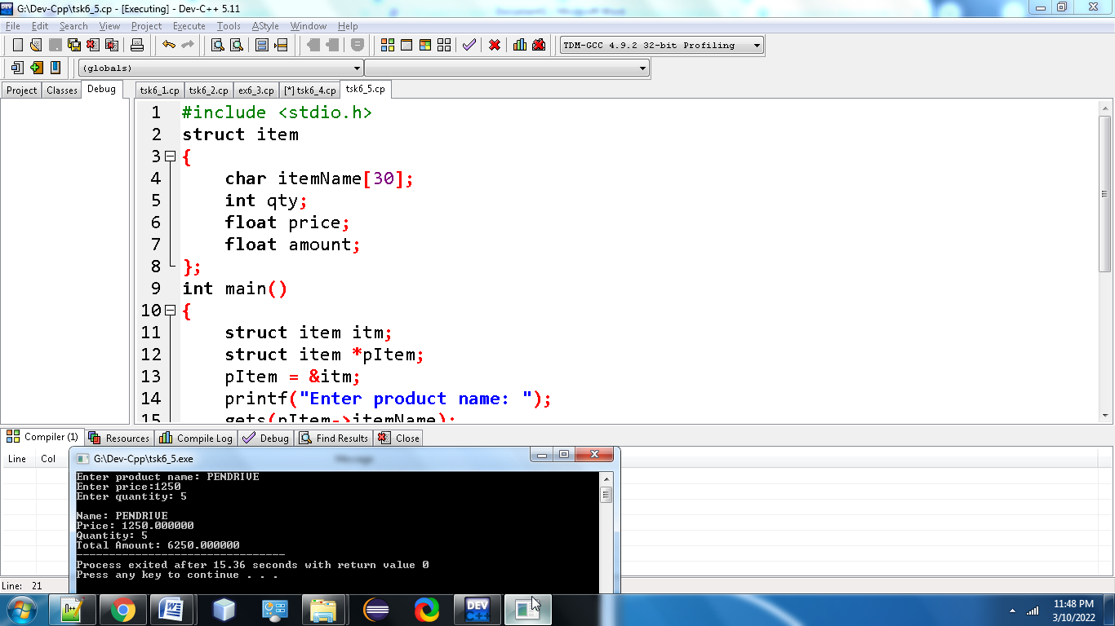**

**6.** [**Write a C program to calculate percentage of student using structure**](https://techstudy.org/cLanguage/Write-a-C-program-to-calculate-percentage-of-student-using-structure)**?**

**#include <stdio.h>**

**struct student**

**{**

**char name [30];**

**int marks[ 5];**

**int total;**

**float percentage;**

**};**

**int main()**

**{**

**struct student std;**

**int i;**

**printf("Enter name: ");**

**gets(std.name);**

**printf("Enter marks:\n");**

**std.total=0;**

**for(i=0;i< 5;i++){**

**printf("Marks in subject %d: ",i+1);**

**scanf("%d",&std.marks[i]);**

**std.total+=std.marks[i];**

**}**

**std.percentage=(float)((float)std.total/(float)500)\*100;**

**printf("\nName: %s \nTotal Marks: %d \nPercentage: %f",std.name,std.total,std.percentage);**

**return 0;**

**}**

**Output:**

**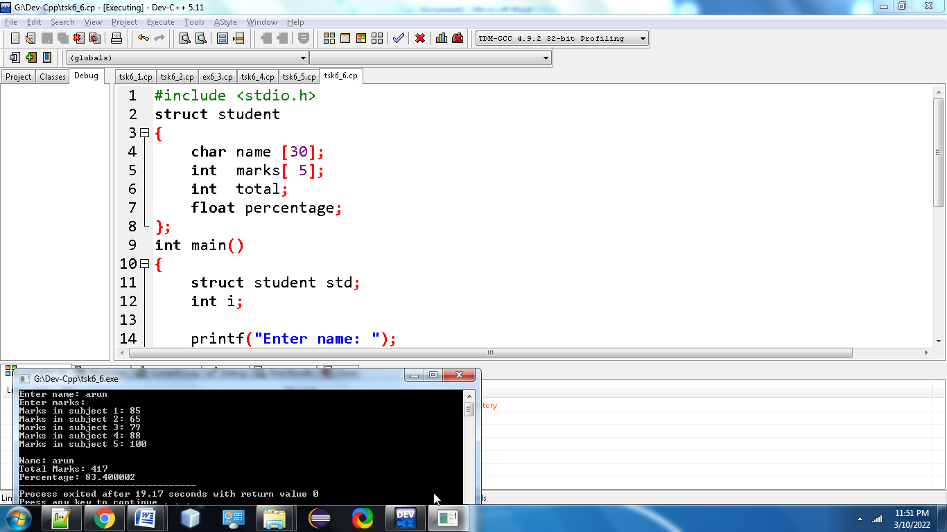**

**7.** **Write a C program to create Book Details using structure?**

**#include<stdio.h>**

**struct book**

**{**

**char book\_name[20];**

**int bookid;**

**float book\_price;**

**char author[15];**

**};**

**int main()**

**{**

**struct book b[3];**

**int i;**

**//clrscr();**

**for(i=0; i<3; i++)**

**{**

**printf("Enter details of book #%d\n", i+1);**

**printf("Enter book id: ");**

**scanf("%d", &b[i].bookid);**

**printf("Enter book name: ");**

**scanf("%s", b[i].book\_name);**

**printf("Enter book author: ");**

**scanf("%s", b[i].author);**

**printf("Enter book price: ");**

**scanf("%f", &b[i].book\_price);**

**}**

**for(i=0; i<3; i++)**

**{**

**printf("\nBook %d.............\n\n", i+1);**

**printf("Book Id: %d\n", b[i].bookid);**

**printf("Book Name: %s\n", b[i].book\_name);**

**printf("Book Author: %s\n", b[i].author);**

**printf("Book price: %f", b[i].book\_price);**

**}**

**return 0;**

**}**

**Output:**

**